DEPOSITS OF THE 1992 NICARAGUA TSUNAMI
Bretwood Higman and Joanne Bourgeois

Abstract
The 1992 Nicaragua tsunami left a deposit that is a sand sheet millimeters to about ten centimeters in thickness, and also cobbles and boulders. Burrows beneath the deposit filled with coarse sediment record the passage of the steep front of the tsunami. Vertical grading is usually normal (fining upward) as is horizontal grading (inland fining). Detailed measurements of horizontal and vertical grading at Playa de Popoyo and nearby areas show local reversals of these grading trends. Horizontal grading of large clasts shows complex patterns including patches and abrupt distal limits to transport. Two locations where vertical grading was measured along the same shore-perpendicular line include specific distributions that can be correlated between locations. These locations show landward fining resulting in one case from a thinning of the coarser basal section of the deposit, and in another case from fining of the basal section. Overall, the simple, single wave of the 1992 Nicaragua tsunami, as recorded on tide gauges, was recorded sedimentologically as a fairly simple, single, normally graded bed.
Introduction
Following a Mw 7.7 earthquake, the September 1992 Nicaragua tsunami was typified by onshore elevation and runup of 4 to 6 m along about 200 km of the Nicaraguan coast (Fig. 1, Satake et al., 1993). The tsunami occurred near high tide (Fig. 2), which maximized its onland effects. No co-seismic subsidence or uplift was detected onshore, and most models of the earthquake place deformation toward the seaward edge of the subduction zone (e.g., Kanamori and Kikuchi, 1993; Imamura et al., 1993; Ide et al., 1993; Satake, 1994, 1995; Piatenesi et al., 1996; Geist, 1999).
Nicaragua 1992 was a typical “tsunami earthquake” (Kanamori, 1972), meaning that it was anomalously efficient in its tsunami generation (Okal and Newman, 2001). Although some authors have invoked a landslide off Nicaragua to explain the high runup (e.g., Herzfeld et al., 1997), models without landsliding can explain nearly all observed runup and tsunami-elevation data (e.g., Titov and Synolakis, 1994; Tanioka and Satake, 1996). Note that tsunami height at the limit of inundation, commonly reported as “true runup,” is partly a function of local topography. The Nicaragua tsunami’s height on land was reduced by about 1% of its penetration distance, so areas where the tsunami penetrated farther had a lower “true runup” (Fig. 3). Other factors such as topographic focusing and wave sloshing affected local tsunami heights, but the data are coherent overall (Fig. 1 and 3).
The coastline of Nicaragua is a mix of rocky headlands and sandy beaches. On average, the southern two thirds of the coastline is rocky and more rugged, projecting southwestward into the Pacific; there are local salinas and lagoons, as at Playa Hermosa, Las Salinas, Playa de Popoyo and Huehuete. The northern coastline is relatively straight, of lower relief, and mostly sandy; several navigable estuaries are present.
The maximum tsunami elevation along the northern coastline was generally less than 4 m; along the central to southern coastline it was typically 4-6 m (Fig. 1). The tsunami apparently had only one damaging wave. The tide gauge record from Corinto harbor (Fig. 2) shows a small retreat and only one large wave (about half a meter on the tide gauge, 2-4 m at the same latitude on the open coast). Eyewitnesses along the Nicaragua coast typically described a single large wave, consistent with the tide gauge record. Some eyewitnesses described the tsunami as two or three waves in quick succession, without any retreat of the water in between.
The tsunami occurred during the rainy season (boreal summer), so coastal water bodies were full and remained full during initial surveys. All later surveys were conducted in the dry season (boreal winter), when many of these lagoons desiccate; these dry lagoons are called salinas, and are commonly mined for salt. Several teams surveyed the runup and damage of the tsunami in the fall of 1992 (Abe et al., 1993; Baptista et al., 1993; Fig. 1), and interviewed local witnesses. Bourgeois participated in a reconnaissance survey of the entire coastline (Satake et al., 1993), visiting most road-accessible localities in late September, 1992, and noting and photographing deposits left by the tsunami. In February, 1993 (six months after the tsunami), Bourgeois conducted a survey of a single site, Playa de Popoyo. She measured five profiles and sampled the tsunami deposit. In March 1995, a joint U.S.-Nicaragua team including Bourgeois conducted nearshore bathymetric surveys at El Velero, Playa Hermosa, El Transito, and Playa de Popoyo. In March 2003 the Popoyo site and Las Salinas were revisited, surveyed and sampled by Higman.

1992 tsunami deposits along the Nicaragua coast
In this section we describe the general characteristics of the tsunami deposits based on 1992, 1993, 1995 and 2003 observations. Where the tsunami runup was greater than about 2 m, there was some evidence of sediment deposited by the tsunami; at sites with 4 m or more of runup, the deposits were generally distinctive, of measurable thickness, and potentially preservable. Deposits described below as "thin" are around 1 cm thick.
Correlations between runup height and deposit properties may be influenced by factors such as local topography and sediment source, as can be shown for the Popoyo site, discussed in more detail in the following section. If we compare Nicaragua deposits to those from the 1960 event in Chile (Bourgeois & Reinhart, 1993), they are less extensive, less distinctive, and less likely to be preserved.
The Nicaragua 1992 tsunami deposits are composed primarily of sand and shell debris eroded from the beach or shoreface. The deposits also include larger blocks of beachrock (naturally cemented beach sediment), plant debris such as uprooted shrubs, and anthropogenic materials such as bricks, cut blocks of tuff (a common wall material), concrete, and roof tiles, as well as clothing and other artifacts.
In most localities evidence of flow direction (flopped-over plants or fallen structures) was landward, except in some inlets where flow was parallel to local contours. Flopped-over plants indicating return flow (toward the sea) were observed in only one case, at Las Salinas. More detailed paleocurrent observations are presented in the survey of Playa de Popoyo (see below).

Site-by-site observations
This is a summary, site by site, from north to south, of observations and interviews made principally by Bourgeois in 1992 (20 September to 1 October), with a few additions from later surveys; localities are on Figure 1.
Jiquilillo. The Jiquilillo/Peninsula Padre Ramos site is located on an estuary, Estero Padre Ramos/Estero San Cayetano. Open-coast runup at this location (about 2 m) barely topped the low spit south of the estuary entrance, and there was minimal damage. There has been, historically, dramatic coastal erosion of the spit, where the town has lost two streets to erosion that predates the tsunami. Thin sand deposits left by the tsunami will be hard to distinguish from underlying beach-ridge sediment, due to their similar character and potential to be reworked. In the interior of the estuary, runup was less than 1 m, and most tide flats are mangrove infested, so the only evidence found of the tsunami was washed-up wood and plant debris. We noted no tsunami effects on intertidal vegetation on sand flats directly landward of the mouth of the estuary. Local witnesses said that a storm in 1982 generated higher water in the estuary and did major damage to mangroves.
Corinto. The town and harbor of Corinto are somewhat protected from the open sea by a rocky headland and spit; tsunami sand deposits were present but subtle at the southern end of the Corinto peninsula. In town, to the north (community of Barrio Nuevo), the tsunami over-topped and eroded an artificial sand barrier and deposited a fan delta of sand within the town. This deposit was most extensive 100 m or more landward of the barrier where flow was unobstructed, down a street perpendicular to the shoreline; the deposit texture mimicked the source of well-sorted fine sand. About 2 km north of town (community of Barrio La Boya), where there was no artificial barrier, a thin layer of sand was present in the yard of a house proximal to the beach. The interior of the estuary at Corinto is similar to Estero Padre Ramos, mangrove infested; the tide gauge in the harbor recorded on the order of a 50-cm first-wave amplitude (Fig. 2). Observers reported little effect of the tsunami on tide flats.
Poneloya. Poneloya is a small beach resort, and has a low sea wall. A thin, mostly continuous layer of sand was present on the lawns just landward of the sea wall, and on floors of the first row of houses.
Playa Hermosa. Runup at Playa Hermosa was less than 4 m, dramatically less than at El Transito just to the south (Fig. 1). At the north and south ends of the embayment, the coastal terrain is upward-sloping, and there was little damage to the few, generally well-constructed houses. Where observed in 1992, the beachface was eroded slightly into a low cliff; the tsunami deposit was thin, extending only tens of meters from the shoreline, and unlikely to be preserved. In 1995, excavations were made in small salinas behind the beach ridge in the center of the embayment, approximately 120 m from the shoreline. The 1992 tsunami deposit – 1 to 8 cm of fine-medium black sand – overlay gray mud and was in 1995 overlain by about 3 cm of brown mud.
El Transito. El Transito was surveyed in detail by the Japanese team (Abe et al., 1993). Runup at this site was as high as or higher than any other site measured, typically 6-8 m, with massive damage to the town. In 1992 Bourgeois visited only the south end of the site, where most of the terrain is natural topography, including a small stream that directed part of the tsunami flow. Where observed, a mostly continuous sheet of gray sand overlay a hard, brown soil surface to a distance inland of no more than 0.5 km. The sand was typically on the order of 1 cm thick, and thinned inland. This site was subsequently heavily reworked by people.
Masachapa. The coastal terrain is upward sloping, and in 1992 some parts of the shoreline had a low seawall. Reported damage was extensive, but bulldozing had already altered much of the near-field area by late September 1992. Landward of the beach a thin layer of sand was observed on the lower parts of the slope. It is unlikely that identifiable deposits will be preserved at this location.
Pochomil. The terrain is relatively flat, including a gently sloping beach profile. A thin sheet of sand was deposited here on the ground, some beach patios, and the floor of a hotel.
Casares. The coastal terrain is overall upward sloping. Some localities had low sea walls. The flow was directed up an inlet splitting the north and south parts of the town. Thin tsunami sand layers were present in both natural settings and on floored structures.
Huehuete. A small lake exists landward of Huehuete, separated from the sea by a low ridge of compact soil. The tsunami overrode the ridge and flowed into this lake, temporarily raising its level (based on eyewitness accounts). The level had returned to its normal rainy-season elevation by 22 Sept.; typically this lake dries up in the dry season. A quick reconnaissance in 1992 near the seaward shore of the lake revealed a tsunami sand 1-2 cm thick, overlying brown and black mud, and overlain by about 1 mm of mud; the deposit thinned landward. Grading of the tsunami deposit was not obvious.
Punta Teonoste. Higman visited a low area between rocky headlands near Punta Teonoste in 2003. He took sand samples from a location about 50 meters from the beach and a few meters from a mangrove slough that in 2003 was blocked by a beach berm. The deposit is interpreted to be from the 1992 tsunami because it lies on top of cohesive sandy soil and extends well into the shrubby forest along the mangrove slough. The site is close enough to the beach, and low enough, that a storm-deposit interpretation cannot be ruled out.
Las Salinas. The tsunami washed up the side of a large, steeply sloping dune, where possible tsunami sand could not be distinguished from the dune sand. Just south of the dune, a low, flat surface was covered with one to several centimeters of gray sand. A trench revealed that this sand was underlain by dark, muddy, soft soil. The deposit was apparently crudely graded, coarsening again at the surface. This surface coarsening is interpreted as a lag left by the backwash, which in this case was strong enough to reorient the local stiff grasses toward the sea – the only place where Bourgeois observed such seaward-directed flopovers.
Higman visited a small salina NW of the dune in 2003. He sampled on a mudflat behind a beach ridge; scattered broken mangrove stumps may be remnants of a destroyed 1992 mangrove swamp. The 1992 tsunami deposit on the mudflat overlies an irregular and locally sandy mud surface and contains some beach gravel and even a small beach cobble. The deposit is obviously graded, and in some places very coarse sand has filled crab burrows in the underlying surface. The location chosen for sampling had a locally more planar base, suggesting it had not been very disturbed since deposition. The deposit was interpreted as a tsunami deposit because it transported cobbles over a vegetated beach ridge with structures on it.
Playa de Popoyo. This site is discussed in detail below. Reconnaissance in September, 1992 was focused principally on runup heights and damage to houses, but tsunami-transported sand and debris was observed to be widespread. This site was visited again in 1993, 1995, and 2003. By 2003 several fields behind the beach ridge had been plowed, destroying the tsunami deposit in those locations.
Northernmost Costa Rica. The terrain at these locales is mostly quite rugged. Runup was typically less than 1 m, and in 1992 Bourgeois observed only transported plant debris and a displaced boat.

Tsunami deposits near Playa de Popoyo
Playa de Popoyo (Fig. 4) is a 2-km-long, straight beach, at about 11º 27’ latitude, which provides an excellent case history of the effects and deposits of a tsunami. Overtopping the beach ridge, the 1992 tsunami reached heights of about 5 m, and at the inland limit its elevation was typically 2-3 m above our datum (top of beachrock on beach; Fig. 3). Sixteen people lost their lives at this site, and most survivors have not returned to live on the Playa. All but three houses along Playa de Popoyo were destroyed beyond repair; the tsunami removed most of them completely from their foundations. These houses were a major source of large clasts in the tsunami deposit (Fig. 5, Table 1). The other source of large clasts was beachrock, some of which crops out along the beach, except in the far north.
The topography of Playa de Popoyo is relatively simple, and the tsunami came over the beach ridge orthogonally, then drained out through low spots (Fig. 4). Interpretation of tsunami routing (see Fig. 4) is based principally on observations of pushed-over and transported vegetation and house parts, as well as on geomorphic features noted in 1992 and early 1993. The northern part of the Playa is typified by a salina behind a single beach ridge (Fig. 5). The salina was covered by about 1 m of water when the tsunami arrived, and was a salt flat in the dry season when surveys were conducted. Toward the south along Playa de Popoyo, the beach ridge is subdued, and topography behind the beach ridge is flat, entirely supratidal, and vegetated (Yellow House, Quinta María Rene, and Mangrove profiles in Fig. 5). At the north and south ends of the Playa, the tsunami followed topographic contours into the lagoon and the mouth of Rio El Limón. Tsunami withdrawal was focused to three low spots—the lagoon entrance, a slough south of the Mangrove profile, and Rio El Limón (Fig. 4).
Inundation distances at Playa de Popoyo range from about 250 to 500 m, except in the salina, which was completely inundated (Fig. 4); inundation was interpreted based on dead vegetation and on wrack lines observed in March 1993. Tsunami deposits extended for most of this distance, although they were thin and very fine toward the landward limit (Fig. 5). The extent of inundation and tsunami deposits increases toward the north. In general, vegetation is denser in the southern part of Playa de Popoyo. By 1995 shrubby vegetation along the entire shoreline had increased in density, and even more so by 2003.
Along the profiles that were measured in 1993 (Fig. 5), the tsunami deposit becomes finer and thinner landward, and fines upward. In seaward proximal deposits a coarse surface layer was present in several localities, and interpreted as a withdrawal scour lag; outside the salina, some wind deflation was observed in 1993. Proximal deposits on the beach ridge are typically 5-10 cm thick and composed of very coarse sand with pebbles and shell debris. The body of the deposit, over most of the profiles, comprises 1-5 cm of coarse to fine sand, fining landward (Fig. 6). Some deposits in the salina exhibit flat to low-angle heavy mineral lamination (Fig. 7). The landward tail of the deposit is less than 1 cm of fine to very fine sand and silt. In most cases large clasts are present for over half of the inundation distance (Fig. 5, Fig. 8, Table 1).

Tsunami deposit grading
Tsunami deposit grading is a reflection of the processes of erosion, transport, and deposition in the tsunami. Differences in vertical grading between proximal and distal portions of the deposit may help constrain how the tsunami is recorded by its deposit. We structured our interpretation of grading in the 1992 Nicaragua tsunami around several questions:
- How do vertical and horizontal grading trends relate?
- At what point(s) in the cycle of erosion, transport, and deposition does sorting occur?
- Are laterally similar layers, appearing to be correlative, deposited at the same time from a flow, or progressively in time (as in progradation)?
- How are different flow features, such as breaking fronts or surges, recorded in the deposit?
Grading within tsunami deposits is commonly described in three ways: proximal to distal, bottom to top, and along the shore. Only proximal-to-distal grading and bottom-to-top grading are treated in this analysis of the Nicaragua tsunami deposit.
The 1992 Nicaragua tsunami near Playa de Popoyo transported everything from mud to boulders, so the deposit contains any sediment that was available for transport. Textural description of such a deposit primarily reflects the sediment source, rather than the tsunami itself. Therefore, a description of change within a deposit, such as grading, is more likely than overall grain size distribution to reflect the processes of erosion, transport and deposition.
The data presented here are grain sizes inferred from terminal-settling-velocity distributions generated using a settling column. We prefer these data over directly measured grain-size data for this study because grains with similar settling velocity but different grain size are likely to behave more similarly than grains with similar size but different settling velocity.
Landward grading
At Popoyo, settling-velocity distributions generally fine landward (Fig. 6), although grading is reversed between some sample pairs. Change in mean grain size is typically around 0.5ø (a factor of 1/√2 in diameter) per 100 meters, although it is much less on the Quinta María Rene profile.
Large-clast grading at Playa de Popoyo is more complex. For example, at the Yellow House profile, a lozenge-shaped field of bricks was strewn in a wake-like pattern between 100 and 160 m from the source house (Fig. 5); The density of clast distribution was lower both seaward and landward of this field of bricks. Also along the Salina, Yellow House, and Quinta María Rene profiles the number of large clasts decreases abruptly near the limit of their extent. Along the Salina profile, at about 300 m inland, this abrupt termination in the blocks is coincident with a transition in the sand-size settling-velocity distributions (Fig. 6, Fig. 8).
Along the Salina profile we counted the number of two different size-classes of large clasts (Fig. 8). Most of these clasts are house fragments, and they appeared to be all of similar density. Overall the ratio between the large (> 20 cm) and medium (< 20 cm) classes has no clear trend. If these clasts were graded to fine landward, this ratio would decrease landward. We also mapped two distinctive groups of bricks, patterned cinderblocks and yellow bricks, coming from one house (Fig. 9).The cinderblocks had a higher source within the house walls than did the yellow bricks. We found that the cinderblocks were less scattered down-flow.
Both of these observations support the idea that the large clasts were distributed throughout the tsunami, rather than concentrated at or near the base. The lack of grading in the large clasts (Fig. 8C) suggests that their transport in the tsunami was not primarily dependent on their size. We think it is unlikely the clasts were transported by sliding or rolling, cases where size influence friction with the bed and degree of coupling to the flow. We interpret the different scattering of the two clast types (Fig. 9) to indicate that source height was the characteristic that distinguished the two populations in their scattering. If so, this pattern indicates that the clasts were distributed throughout the tsunami water column, not concentrated at the base of the flow during their transport. However, these patterns may not be representative of cobbles or boulders in natural settings, as the clasts in question were “entrained” from standing structures, not from the bed.
Vertical Grading:
Vertical grading was measured in tsunami deposits from five trenches where sets of vertically contiguous samples were collected (Fig. 10). Normal grading dominated in each case, but a small section of inverse grading was present at the base of all but the proximal Playa de Popoyo deposit. Generally, grading was weaker and grain-size distributions narrower at the top of each deposit. These similarities in grading pattern occur in spite of differences in the overall distribution of sand size among the locations sampled.
Playa de Popoyo. In the salina at Playa de Popoyo, sets of vertically contiguous samples were taken from trenches at two locations at distances of about 200 and 250 meters from the beach. These trenches were along a line where the deposit was consistently over three times as thick as the usual three centimeters observed in most of the salina. We used detailed measurements of the samples to correlate grain-size distributions between the proximal and distal trenches (Fig. 11). The distributions are very similar between the upper part of the proximal deposit and two different portions of the base of the distal deposit We favor the upper of these grain-size correlations because it is additionally associated with an abrupt jump in mean grain size and a layer of rip-ups in both deposits.
The similarity in grain size, grading structure, and relative rip-up concentration between the two points is probably a reflection of the sorting process rather than a marker for simultaneous deposition. At any given moment, the water passing over these locations is different, and is carrying sediment eroded either from different places or at different times. Also, the flow conditions are unlikely to be homogeneous at any given time, as tsunami flows are always changing, and it takes time for changes to propagate through space. However, the similarity in the material deposited (grain-size distribution and rip-ups) and the similarity in the grading structure of the deposit (abrupt fining overlain by subtle grading) suggests that the process most responsible for vertical variation in grain-size distribution was similar between the two locations. The sorting may occur during either erosion or deposition (or both):
Case 1: Erosional sorting: Sorting reflects a biased removal of sediment from the source. The similar sections in the two deposits reflect sediment deposited from the same water at different times. They are similar because little sorting occurred during transport and deposition, so the sorting processes involved in erosion set the distribution that a given section of the flow laid down as it propagated inland.
Case 2: Depositional sorting: Sorting reflects a biased addition of sand to the deposit. The similar sections in the two deposits reflect sediment eroded from a homogenized source and then sorted during deposition. When the same process acted to the same extent on the same source sediment, the sediment deposited would be the same.
Our data are insufficient to distinguish these two cases. However, each cases makes different predictions about how different parts of the tsunami flow would be recorded in the deposit. If most sorting occurred during erosion, then it was the conditions at the sediment source that controlled grading, except that it was the conditions at the point of deposition that controlled whether deposition occurred. If instead most sorting occurred during deposition, then the source only set the overall distribution of sediment in the deposit, and it was conditions near the point of deposition that were recorded.
Las Salinas. Just north of Playa de Popoyo, in a salina near Las Salinas, we measured vertical grading in two trenches about 35 meters apart perpendicular to the beach (Fig. 10). Correlations of grain size distributions, drawn and interpreted in a similar way as in the Playa de Popoyo salina, show little lateral change in the deposit, except for fining of the base of the deposit and also of patches of sediment in local depressions (Fig. 12).
In this salina, there were burrows and other depressions that were filled with sand before the main deposit formed (Fig. 12). Sediment in the depressions is coarser than the main sand sheet. The depressions varied in geometry, but some burrows were deep enough that it is likely that any grain that reached there was deposited permanently. Thus burrow deposits should be a record of the first water in the flow. Eyewitnesses described the tsunami approaching as a breaking bore, so the front of the wave probably had greater basal shear stress and turbulence than the water immediately behind it. High shear and strong mixing is ideal for the entrainment and transport of coarse sediment such as what is plugging the depressions along an otherwise erosive bed.
Discussion
Grading in the deposit is similar at all locations studied along the coast, suggesting that this grading reflects sorting processes in the tsunami rather than in the sediment source. There are variations in sediment source, as reflected in variable grain-size distributions along the coast. It is unlikely that every location would show dominantly normal grading that became less strong toward the top if this grading were a result of local source conditions.
Discrete, coarse-sediment-filled pockets below a tsunami sand sheet, such as the burrow fillings in this case, may provide distinct records of steep bore-fronted flows such as tsunamis and turbidity currents. Storms rarely approach as a breaking bore, so depressions plugged with coarse sediment might provide a criterion for distinguishing storm and tsunami deposits.
The tsunami deposit reflects the tsunami flow on various spatial scales, from 10s of meters to kilometers or more. The wave in this area and probably across much of Nicaragua was simple. There was only a single large wave, and in the sites studied beach ridges limited the strength of withdrawal. Deposit grading is therefore simple, and consistent from place to place. Some features, such as subtle grading at the top of the deposit, are consistent all along this section of coast. Other features, such as the abrupt jump to finer grain size overlain by rip-ups in the Playa de Popoyo salina, are consistent between closely spaced trenches, but do not extend between locations. There are also differences between trenches that are close together. These variations reflect spatial variation in the temporal flow structure of the tsunami and show that deposits have the fidelity to record both large-scale tsunami structure, and local variation.

Acknowledgments
We would like to thank Andrew Mattox, Jose Borrero, Costas Synolokis, Harry Yeh, Becquer Fernandez, and Gordie Harkins for their participation in the post tsunami surveys, and David Trippett for assistance with laboratory analysis of samples. Brian Atwater provided critique that led to substantial improvement in our figures.
References

Abe, Kuniaki, Abe, Katsuyuki, Tsuji, Y., Imamura, F., Katao, H., Yoshihisa, I., Satake, K., Bourgeois, J., Noguera, E., Estrada, F., 1993. Field survey of the Nicaragua earthquake and tsunami of September 2, 1992. Bulletin of the Earthquake Research Institute = Tokyo Daigaku Jishin Kenkyusho Iho. 68; 1, p. 23-70.

Baptista, A.M., Priest, G.R., Murty, T.S., 1993. Field survey of the 1992 Nicaragua tsunami: Marine Geodesy, v. 16, p. 169-203.

Bourgeois, Joanne, Reinhart, Mary Ann, 1993. Tsunami deposits from 1992 Nicaragua event; implications for interpretation of paleo-tsunami deposits, Cascadia subduction zone. Eos, Transactions, American Geophysical Union. 74; 43, Suppl., p. 350.

Fernandez, Mario, Havskov, Jens, and Atakan, Kuvvet, 1999. Destructive tsunamis and tsunami warning in Central America. Science of Tsunami Hazards. 17; 3, p. 173-186.

Geist, Eric L., 1999. Local tsunamis and earthquake source parameters. in: Tsunamigenic earthquakes and their consequences. Dmowska-Renata (editor); Saltzman-Barry (editor) Advances in Geophysics. 39; Pages 117-209.

Goff, J., McFagden, B.G., Chague-Goff, C., 2003. Sedimentary differences between the 2002 Easter storm and the 15th century Okoropunga tsunami, southeastern North Island, New Zealand. Marine Geology 34, p. 1-16.

Harlow, David H. and White, Randall A., 1992. Forecast of earthquake in western Nicaragua.
Science. 258; 5083, p. 726.

Herzfeld, U.C., von Huene, R., Kappler, W., and Mayer, H., 1997. Characterization of high-resolution geomorphological processes; slumps on the slope of the Middle America Trench.
Proceedings of IAMG '97, the Third Annual Conference of the International Association for Mathematical Geology (IAMG). Pawlowsky-Glahn-Vera (editor), p. 585-590.

Ide, Satoshi, Imamura, F., Yoshida, Y., Abe, Ka., 1993. Source characteristics of the Nicaraguan tsunami earthquake of September 2, 1992. Geophysical Research Letters. 20; 9, p. 863-866.

Ihmle, Pierre F., 1996. Frequency-dependent relocation of the 1992 Nicaragua slow earthquake; an empirical Green's function approach. Geophysical Journal International. 127; 1, p. 75-85.

Ihmle, Pierre F., 1996. Monte Carlo slip inversion in the frequency domain; application to the
1992 Nicaragua slow earthquake. Geophysical Research Letters. 23; 9, p 913-916.

Imamura, Fumihiko, Shuto, N., Ide, S., Yoshida, Y., Abe, Ka., 1993. Estimate of the tsunami source of the 1992 Nicaraguan earthquake from tsunami data. Geophysical Research Letters. 20; 14, p. 1515-1518.

Kanamori, H., 1972, Mechanism of tsunami earthquakes, Phys. Earth Planet. Inter., 6, 246-259.

Kanamori, Hiroo, 1993. W phase. Geophysical Research Letters. 20; 16, p. 1691-1694.

Kanamori, Hiroo, Kikuchi, Masayuki, 1993. The 1992 Nicaragua earthquake; a slow tsunami earthquake associated with subducted sediments. Nature (London). 361; 6414, p. 714-716.

Kikuchi, Masayaki, Kanamori, Hiroo, 1995. Source characteristics of the 1992 Nicaragua tsunami earthquake inferred from teleseismic body waves. In: Tsunamis; 1992-1994, their generation, dynamics, and hazard. Satake-Kenji (editor); Imamura-Fumihiko (editor) Pure and Applied Geophysics. 144; 3-4, Pages 441-453.

Moore, Andrew, Ph.D. dissertation (for densities of clasts)

Nanayama, F., Shgeno, K., Satake, K., Shimokawa, K., Koitabashi, S., Miyasaka, S., and Ishii, M. 2000. Sedimentary differences between the 1993 Hokkaido-nansei-oki tsunami and the 1959 Miyakojima typhoon at Taisei, southwestern Hokkaido, northern Japan: Sedimentary Geology, v. 135, p. 255-264.

Okal, Emile A. and Newman, Andrew V., 2001. Tsunami earthquakes; the quest for a regional signal: Physics of the Earth and Planetary Interiors. 124; 1-2, p. 45-70.

Okal, Emile A., Alasset, Pierre, Hyvernaud, Olivier, and Schindele, Francois, 2003. The deficient T waves of tsunami earthquakes. Geophysical Journal International. 152; 2, p. 416-432.

Piatanesi, Alessio, Tinti, Stefano, and Gavagni, Ivan, 1996. The slip distribution of the 1992 Nicaragua earthquake from tsunami run-up data. Geophysical Research Letters. 23; 1, p 37-40.

Satake, Kenji, 1994. Mechanism of the 1992 Nicaragua tsunami earthquake. Geophysical Research Letters. 21; 23, p. 2519-2522.

Satake, Kenji, 1995. Linear and nonlinear computations of the 1992 Nicaragua earthquake
tsunami. In: Tsunamis; 1992-1994, their generation, dynamics, and hazard. Satake-Kenji (editor); Imamura-Fumihiko (editor) Pure and Applied Geophysics. 144; 3-4, p. 455-470.

Satake, Kenji, Bourgeois, J., Abe, Ku., Abe, Ka., Tsuji, Y., Imamura, F., Iio, Y., Katao, H., Noguera, E., Estrada, F., 1993. Tsunami field survey of the 1992 Nicaragua earthquake.
Eos, Transactions, American Geophysical Union. 74; 13, p. 145, 156-157.

Schindele, F., Reymond, D., Gaucher, E., Okal, E.A., 1995. Analysis and automatic processing in near-field of eight 1992-1994 tsunamigenic earthquakes; improvements toward real-time tsunami warning. In: Tsunamis; 1992-1994, their generation, dynamics, and hazard.
Satake-Kenji (editor); Imamura-Fumihiko (editor) Pure and Applied Geophysics. 144; 3-4, p. 381-408.

Tanioka, Yuichiro, and Satake, Kenji, 1996. Tsunami generation by horizontal displacement of ocean bottom: Geophysical Research Letters, v. 23, p. 861-864.

Titov, V.V. and Synolakis, C.E., 1994. A numerical study of wave runup of the September 2, 1992 Nicaraguan tsunami: Proc. IUGG/IOC Int. Tsunami Symposium, p. 627-635.

Tsuboi, Seiji, 2000. Application of M (sub wp) to tsunami earthquake.
Geophysical Research Letters. 27; 19, p 3105-3108.

Velasco, A.A., Ammon, C.J., Lay, T., Zhang, Jiajun, 1994. Imaging a slow bilateral rupture with broadband seismic waves; the September 2, 1992 Nicaraguan tsunami earthquake. Geophysical Research Letters. 21; 24, p. 2629-2632.

Zhang, Jiqjun, 1998. Inversion of surface wave spectra for source parameters of large
earthquakes using aspherical earth models. Physics of the Earth and Planetary Interiors. 107; 4, p. 327-350.

TABLE 1: Large clasts surveyed (March 1993) and other basic observations
Material | Distance (m) | Dimensions | Notes
 | from source* | (cm)
Profile 1 (south of Quinta María Rene)
beachrock | 5 | 230x160x45 | minimum vertical 1.5 m
beachrock | 65 | 36x15x5 | begin field of house blocks
beachrock | 75 | 35x20x5 | last large beachrock
wall | 50 | 54x23x18
wall | 50 | 90x54x18
wall | 70 | 112x78x25
wall | 100 | 47x44x11 | last large clast
field of blocks | 25-120 | many 10-20 cm diameter
limit of sand | ~200
water limit | ~300
Profile 3 (Mangrove)
beachrock | 20 | 100x75x16 | first large block
beachrock | 30 | 124x117x24
beachrock | 35 | 120x74x23 | tilted on tree
beachrock | 50 | 100x72x13
beachrock | 60 | 70x50x25 | against fence
beachrock | 85 | 120x75x15 | clast is very scalloped
beachrock | 90 |  | last rocks about here
limit of sand | ~200
last debris | ~250 |  | floating debris (woody)
Profile 4 (Yellow House)
beachrock & walls |  | not measured | against tree
wall | 40 | 80x65x14
wall | 50 | 120x112x14
tuff block | 50 | 43x34x16
beachrock | 110 | 75x65x20
wall | 75 | 143x67x14
beachrock | 140 | 89x84x17
field of bricks | 100-200 | many clasts of 1-4 bricks
wall | 160 | 87x71x14 | large wall blocks
wall | 170 | 85x76x14 | common near 15
wall | 200 | 85x58x14
last wall pieces | 220 | not measured
last bricks | 240 | not measured
limit of sand | ~300
last debris | ~300 | less dense than bricks
 |  | (roofing, wood,…)
*The source is generally either the zone of beachrock, or a house foundation
In the case of beachrock, the distance is a minimum.

Appendix: Field and Laboratory Protocols
Sea level data. Most of the tsunami elevation data were collected in late September 1992, and corrected (with tide tables) from tide level on the day of measurement to tide level at the time of the tsunami, just after high tide on 1 September 1992. In most cases, a hand level and stadia rod were used, and distances estimated, mapped, or measured by GPS.
In March, 1993, five profiles were measured across the Playa de Popoyo (Fig. 4,5), using a tripod, transit level and stadia rod. On the profiles, the water level at the time of the 1992 tsunami is estimated and used as datum ( = 0). This estimate is based on local observation of high tide over several days, which typically came to a level just below the upper beachrock step. This level also corresponds to the limit of grassy vegetation in the salina. The tsunami elevation data collected in September 1992 are plotted onto the profiles, but only some were remeasured, so these elevation data may have an error on the order of 10s of cm.
Proximal to distal sampling. In March 1993 four of the profiles were sampled for tsunami deposits (Fig. 8), associated with survey points along the profiles. Because it was dry season, the tsunami deposits were loose, and some wind deflation had taken and was taking place. Some of the finer sediment was blown away during sampling. Bourgeois tried to take a representative sample of the entire deposit, top to bottom. The best samples were from the Salina profile, because they were damp, and capped by mud, except the most distal cases, which were exposed and dry. During the 2003 return trip to Nicaragua, Higman outlined 10-m long and 15-m wide rectangles along the Salina profile, and counted the number of bricks in each in two categories, one with a median diameter between 10 and 20 cm, the other with a median diameter greater than 20 cm.
Vertical sampling. No vertical sampling was done during the 1993 or 1995 visits. In 2003, none of the locations where profiles had been measured in 1993 proved suitable for collecting vertical grading samples. However, in three other locations, one close to the Salina profile, Higman collected vertically distributed samples. To sample for vertical grading, we cleaned the upper surface of the deposit and cut a small tablet of sand out with a knife. When this sample was completely removed, leaving a flat surface below, another tablet was cut out as the next sample. This technique yielded samples that were contiguous and minimally mixed with adjacent samples. The top of the salina deposit, where it is mixed with overlying mud, was not sampled.
Analysis. For analysis these samples were split to less than 0.7 g submerged weight and run through a 189-cm settling column. Cumulative submerged weight vs. time data from the settling column were used to estimate equivalent grain size of silica spheres. The plotted distributions have arbitrary proportion units with constant area.

FIGURE CAPTIONS

Figure 1. Location map and plot of 1992 Nicaragua tsunami elevations in Nicaragua and northernmost Costa Rica, as reported by Abe et al., 1993; Satake et al., 1993; and Baptista et al., 1993. Note that many of these measurements are not “true runup” (elevation at inland limit of inundation) (see text and Fig. 3). Points are coded as “high” or “moderate” confidence depending on the reliability of the marker for tsunami height that was used.

Figure 2. Tide gauge record of the 1992 Nicaragua tsunami from the port of Corinto, within an embayment. Note the single relatively large positive wave, following initial withdrawal. Tsunami heights on the outer shore at this latitude were 2-4 m (Fig. 1)

Figure 3. Plot of tsunami elevation and distance from shore, from Playa de Popoyo (this paper) and El Transito, Masachapa, and San Juan del Sur (reported in Abe et al., 1993). Tsunami height at the limit of inundation was usually marked by floating debris. Other indicators included water marks, tree scars, damage to structures, and seaweed in vegetation. A best fit 1% slope is depicted to illustrate that the reduction in height with distance is similar at different sites.

Figure 4. Overview map of Playa de Popoyo taken from a 1:50,000 topographic sheet, showing profile (Fig. 5) locations and tsunami effects recorded in 1992 and 1993. Current indicators were measured in March 1993. Houses plotted north of “Yellow House” are schematic. Limits of tsunami inundation and deposit are approximate, except along profiles, and as noted around the salina in March 1993.

Figure 5. Profiles (mapped in Fig. 4) measured and described in March 1993 (excluding “Beachrock”). See appendix for notes on protocol. Tsunami-sand thickness is generalized from point observations (small excavations at 10-20 points per profile). Positions of large clasts are generalized; see Table 1 for some more specific large-clast data.

Figure 6. Grain-size distributions of 1992 Nicaragua tsunami deposits sampled in 1993 along four measured profiles at Playa de Popoyo (Fig. 5). The mean grain size is plotted vs. distance above each profile. On the mean grain size plot, the analytical error is less than the size of the dot. See appendix for comments on sampling.

Figure 7: Internal structure of the 1992 Nicaragua tsunami sand sheet. Sketch and photo from a 2003 trench in the Popoyo salina, about 100 m NW of the “Salina” profile and about 250 m from the beach, where the deposit is particularly thick and undisturbed. Heavy-mineral laminae are visible at a variety of different depths in the deposit, however one particularly prominent lamina divides the deposit approximately in half in many places. Also noted on the sketch are rip-up clasts (< 1 cm diameter), which most commonly occur directly below the prominent lamina. At the distal end of the sketch, several tire tracks have pushed the deposit down into the soft underlying mud.

Figure 8: Summary of data collected on the distribution of blocks along the Popoyo “Salina” profile (Fig. 4). Almost all of the blocks along this profile were house fragments, including tuff blocks, reinforced concrete, and large sections of intact brick walls. The profile was divided into 10-m long and 15-m wide rectangles, and all solid blocks larger than a few centimeters within each section were counted and categorized by median length. Most blocks in the “medium” category (< 20 cm) were individual bricks, while those in the “large” category (> 20 cm) were multiple bricks connected together, or concrete, or especially large bricks. Blocks with very high surface areas, such as tiles and cinderblocks, were not counted. The dots mark the ratio between the number of large blocks and the number of medium blocks within each 10-m increment. Ratios for counts of less than ten blocks are excluded.

Figure 9: GPS map (2003) showing distribution of tsunami-transported blocks on the Popoyo salina, approximately along the “Salina” profile (Fig. 6). Two different distinctive brick types from a single house are plotted. The patterned cinderblocks appeared to have come from high on the wall around the bathroom, while the yellow bricks formed complete walls of the house. Solid boundaries are GPS-mapped, including the landward limit of scattered blocks, which is abrupt.

Figure 10: Grain-size distributions for five vertically distributed sample sets collected in 2003. For each trench, the mean grain size is plotted vs. depth, all the distributions are overlain to make a composite distribution, and each distribution is plotted separately to the right. For the mean grain size vs. depth plot, the height of rectangular marks indicates the depth range that was sampled, while the width is one standard deviation of at least three separate analyses of the same sample (an estimate of standard error). The only exception to this is “Las Salinas” (distal) where samples were run only once, in which case a mark that is an estimate of standard error is plotted.

Figure 11: Stratigraphy and interpretation of two trenches in the salina at Playa de Popoyo (located on Fig. 7 map). The grain size data for these trenches is reported in Figure 10. These trenches were about 100 meters north of the Salina profile, and were about 200 (proximal) and 250 (distal) meters from the ocean. For the stratigraphic sections, the width of the section is related to the mean grain size of samples collected at different depths (see appendix on vertical sampling). Wider parts of the stratigraphic section have coarser sediment. The tops of both of these trenches were not sampled. A correlation is noted where the top of the proximal deposit is similar in structure and composition to the base of the distal deposit.

Figure 12: Stratigraphy and interpretation of two sections in a salina near Las Salinas (located on map insert Fig. 10). These sections are both part of a 50-meter-long trench across a portion of thicker and less disturbed deposit about 200 meters from the ocean. No profile was measured here; however it was generally similar to other measured profiles with a beach ridge separating the salina from the ocean (e.g., the Popoyo “Salina” profile, Fig. 5). Along this long trench ten depressions and burrows filled with particularly coarse sediment were sampled, and the grain-size data for depressions nearest the two sections are reported here. Grain size correlations between the two sections show little change in the upper two thirds of the deposit, but a marked lateral fining of the basal sections and depression fills.

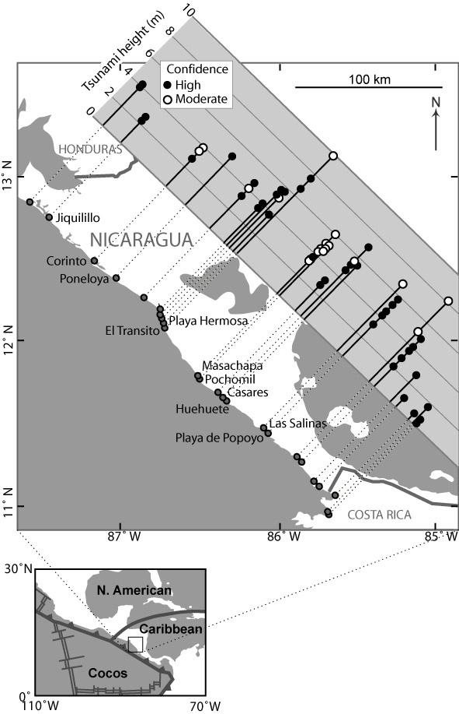

Figure 1
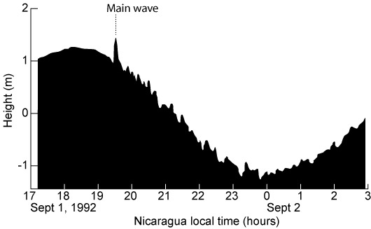
Figure 2

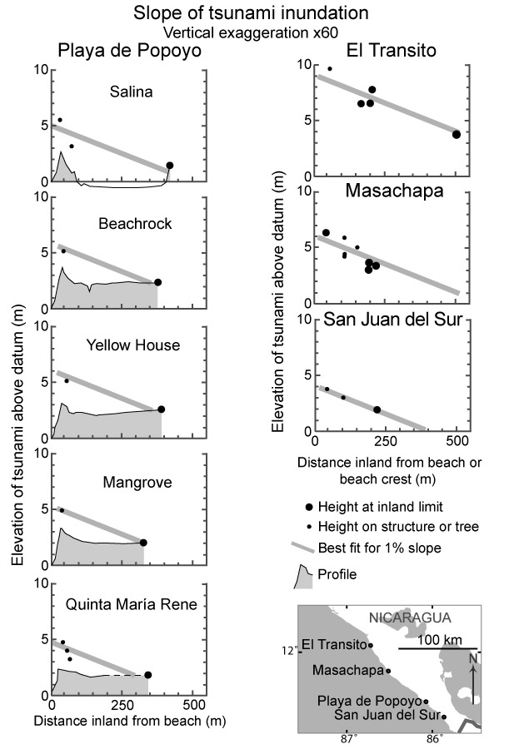

Figure 3

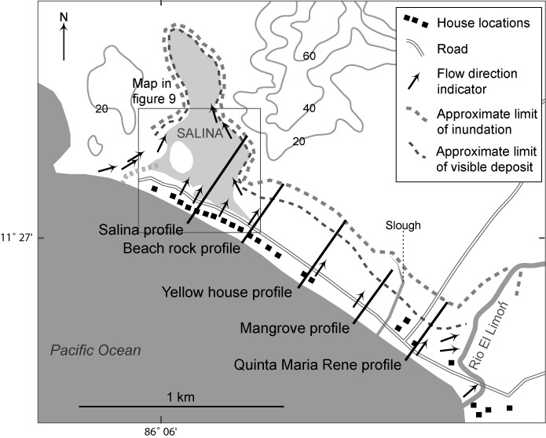

Figure 4

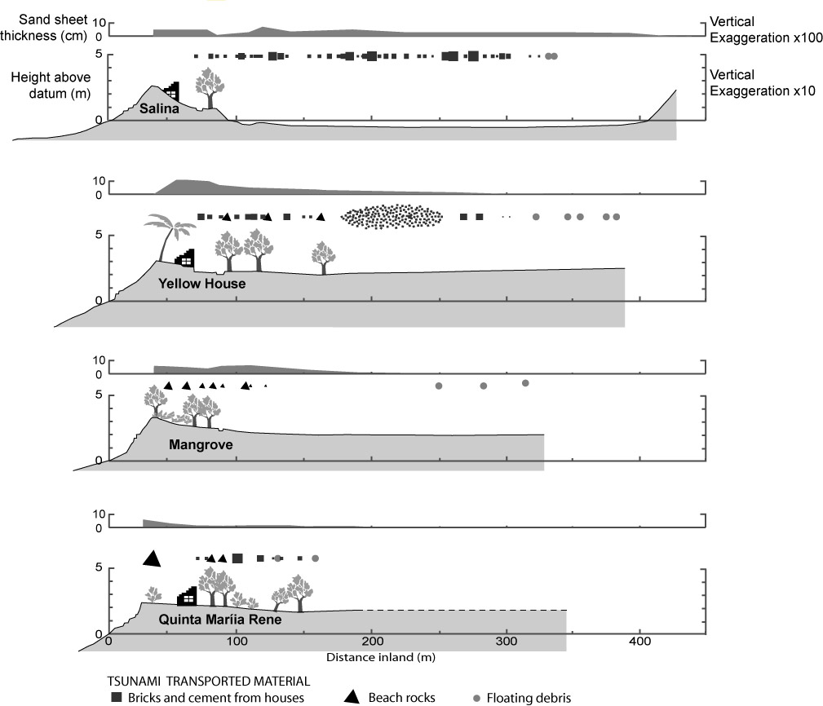

Figure 5

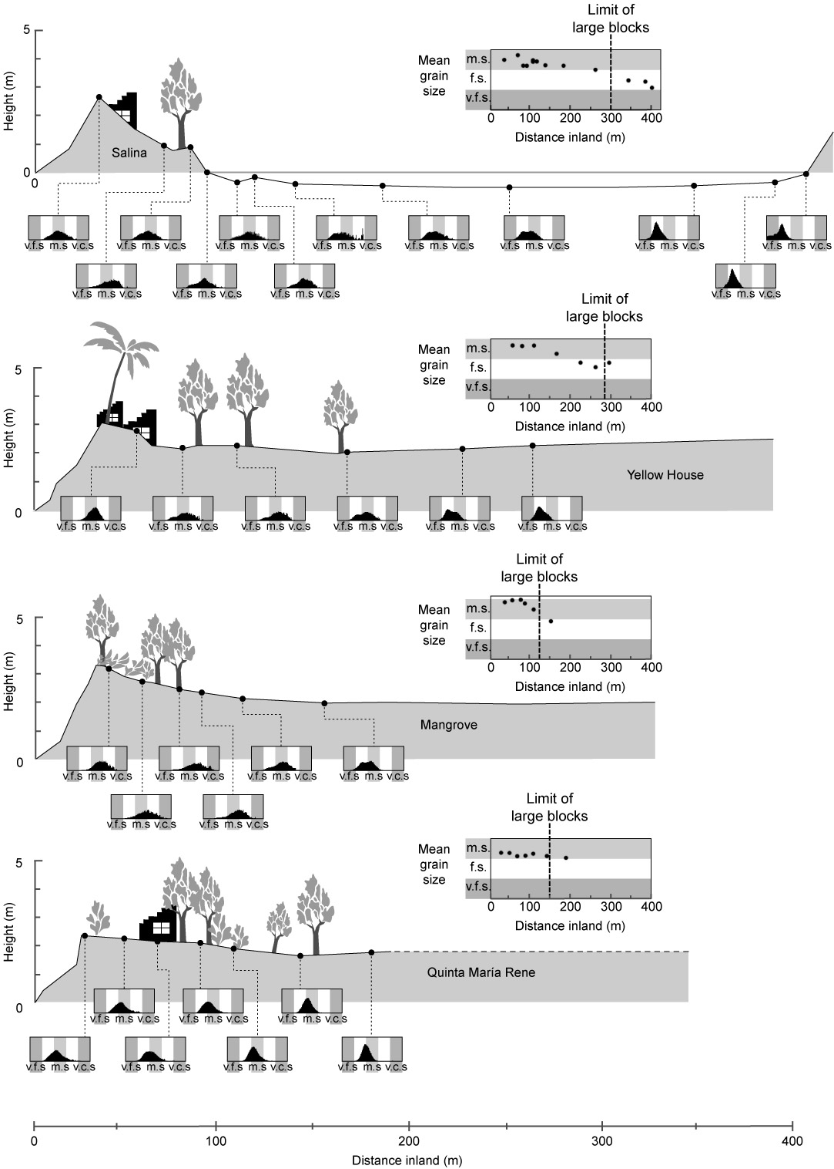
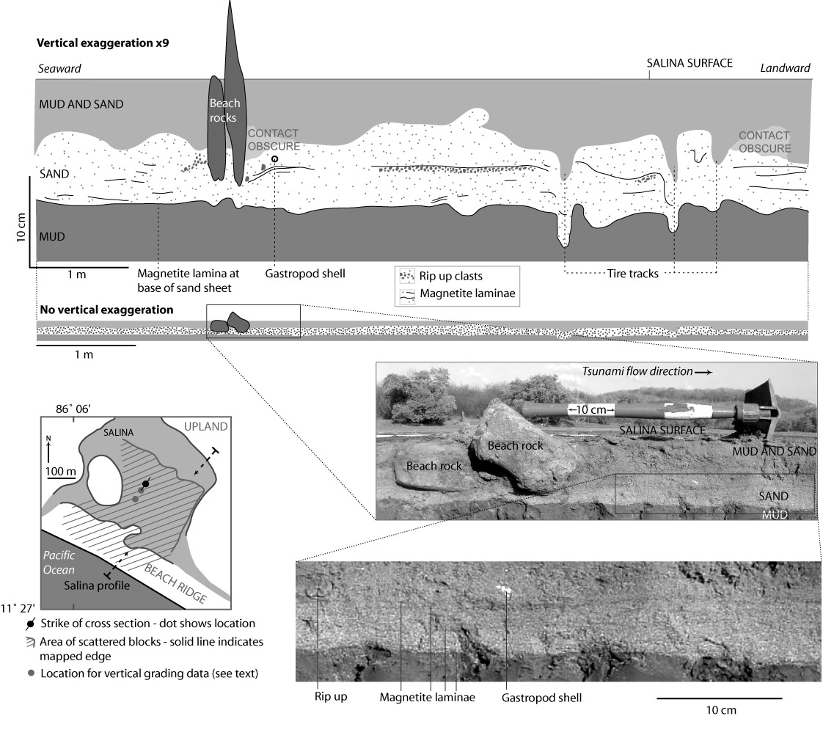

Figure 7

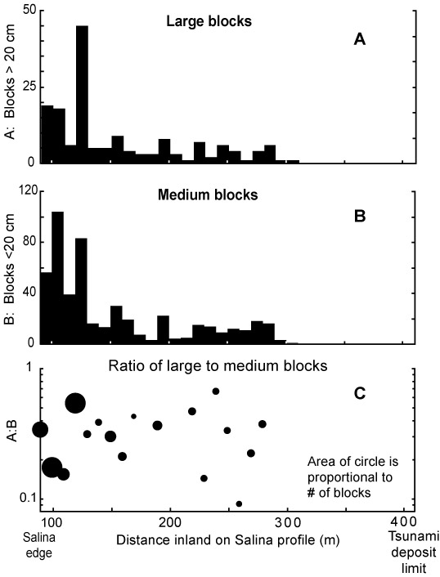

Figure 8

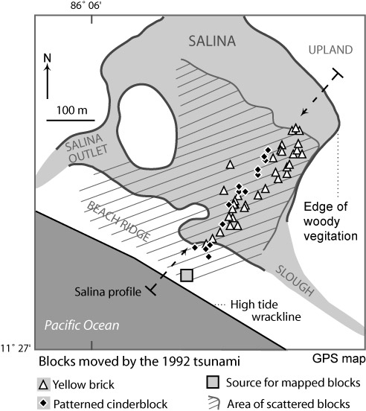

Figure 9

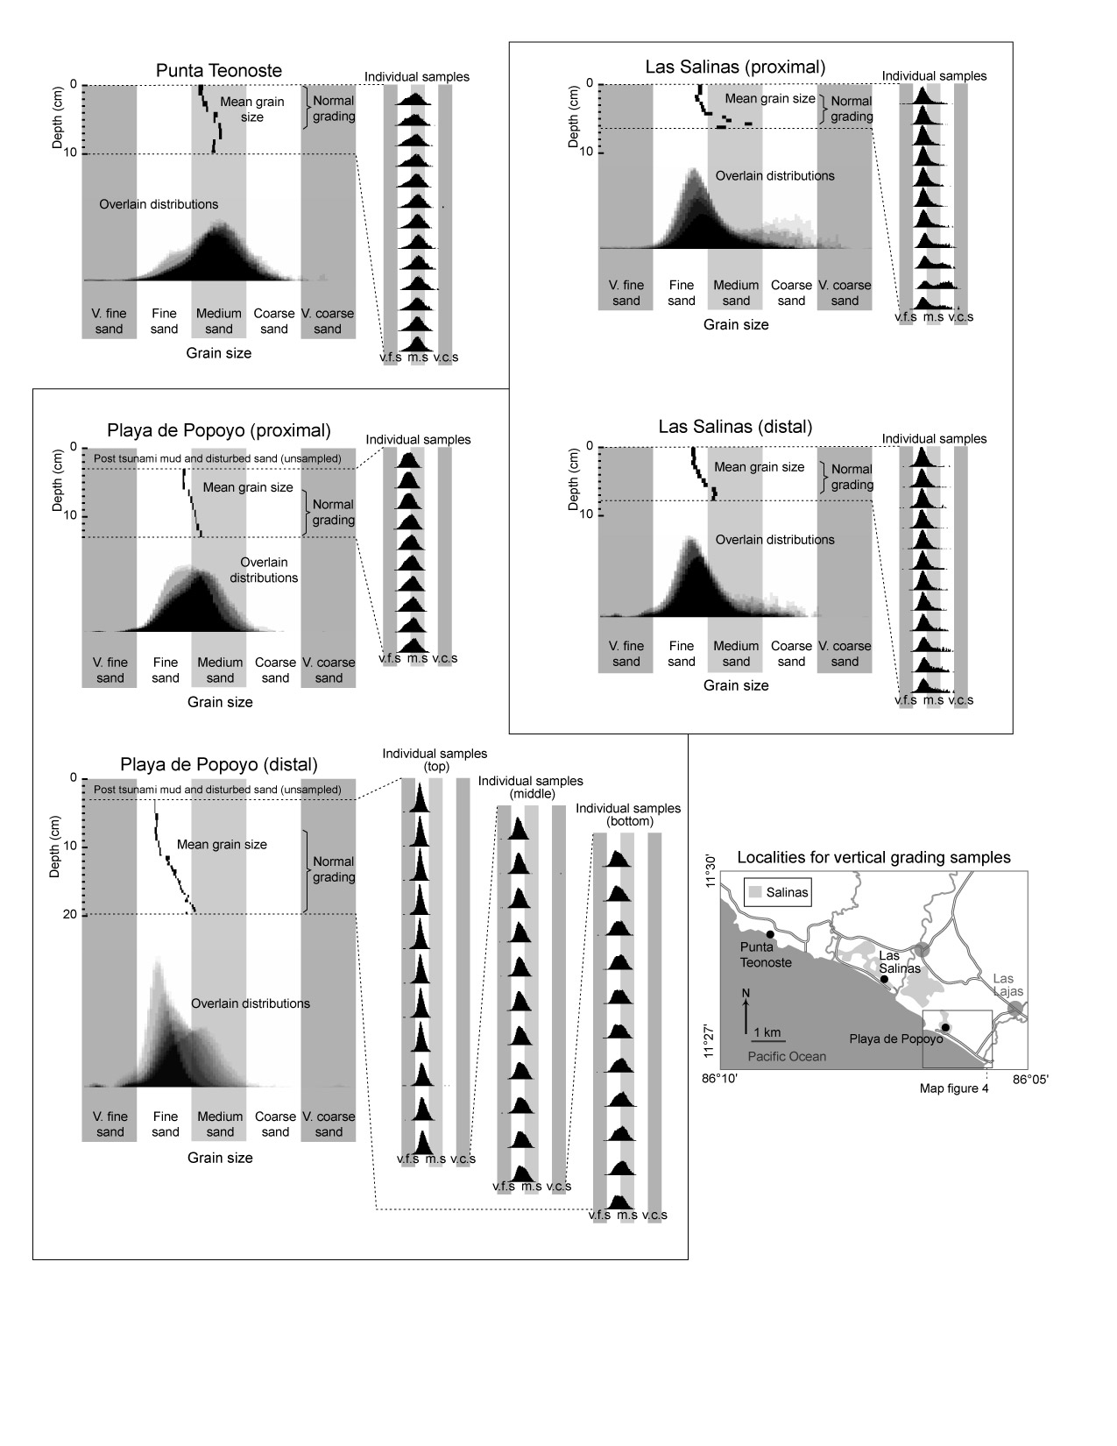

Figure 10

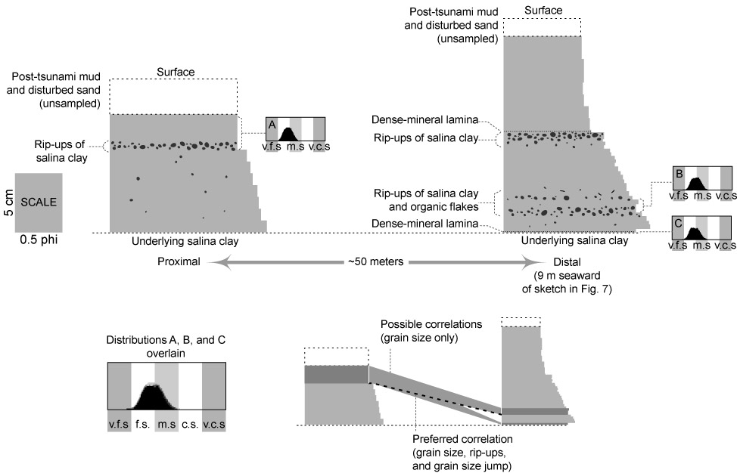

Figure 11

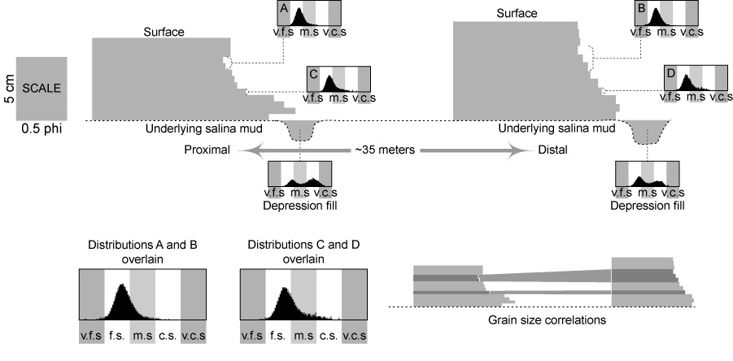

Figure 12

In this paper, we use “proximal” to mean closer to the shoreline (the sediment source for the tsunami), and “distal” to mean farther landward from the shoreline.

